Chapter 5, Solution 14.

Transform the current source as shown below. At node 1,

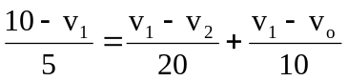

20 kΩ
10 kΩ
10V

+
−
v₁
−
+
+
v_{o}
−
v₂
v_{o}
10 kΩ
5 kΩ

But v₂ = 0. Hence 40 – 4v₁ = v₁ + 2v₁ – 2v_{o} 40 = 7v₁ – 2v_{o} (1)

At node 2, 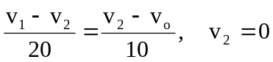 or v₁ = –2v_{o} (2)

From (1) and (2), 40 = –14v_{o} - 2v_{o} v_{o} = –2.5V

